**Cloud Service Models**

Cloud computing has revolutionized the way individuals and organizations access and manage computing resources. Rather than investing in expensive physical infrastructure, users can now leverage cloud-based services over the internet.

These services provide on-demand access to storage, processing power, databases, and applications, all managed remotely by cloud providers.

This approach significantly reduces costs, improves scalability, and enhances accessibility for users across the globe.

Cloud services are commonly categorized into three major models:

* **Infrastructure as a Service (IaaS)**
* **Platform as a Service (PaaS)**
* **Software as a Service (SaaS)**

These models represent different levels of abstraction and control for users, forming what is often called the **"cloud stack."**

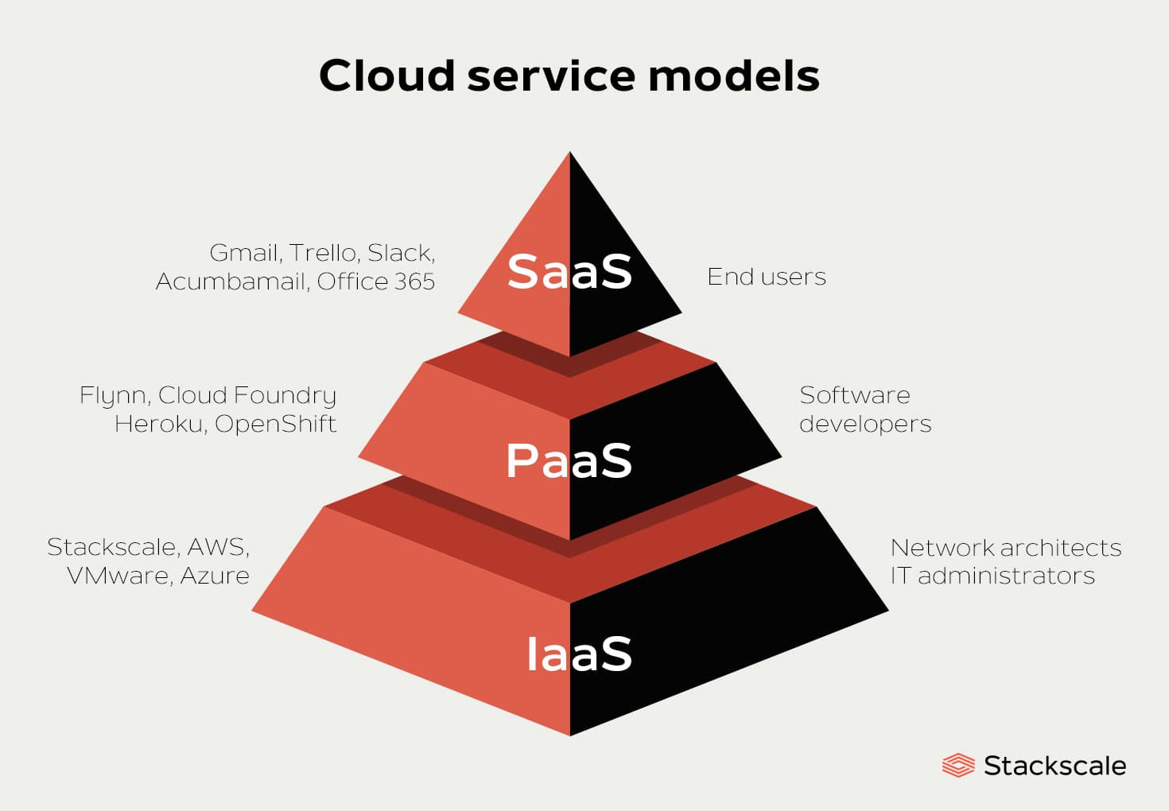

**Infrastructure as a Service (IaaS)**

* IaaS provides the most fundamental building blocks for cloud IT. It offers **virtualized computing resources** like servers, storage, and networking hardware through the internet.
* Users have full control over the operating systems and deployed applications, making IaaS highly flexible. However, they are also responsible for managing everything from the OS level up.
* This model is ideal for system administrators and DevOps engineers who need full control without investing in physical data centers.
* Examples include **Amazon EC2**, **Microsoft Azure Virtual Machines**, and **Google Compute Engine**.
* IaaS is widely used for hosting websites, data backups, testing environments, and running legacy applications.

**Advantages:**

* + **Full control** over infrastructure.
  + **Scalable** – Easily add or remove servers.
  + Ideal for companies needing **custom environments** or **high-performance computing**.

**Target Audience:**

* IT administrators
* System architects
* DevOps engineers
* Imagine you want to start a website. Instead of buying your own server, you rent one from a cloud provider like AWS or Azure. You use their virtual server, storage, and network, but **you control what runs on it**—your website, apps, and data.
* You install the OS, set up security, and manage updates. This gives you flexibility but also more responsibility.

**Platform as a Service (PaaS)**

* PaaS offers a **development and deployment environment in the cloud**. It includes resources such as operating systems, databases, middleware, and development tools that allow developers to build, test, and deploy applications quickly.
* The cloud provider manages everything below the application layer, so developers can focus on coding and logic rather than infrastructure management.
* Popular PaaS platforms include **Google App Engine**, **Heroku**, and **Microsoft Azure App Services**.
* This model is especially beneficial for startups, student projects, and teams practicing agile development, as it speeds up deployment and simplifies operations.

**Advantages:**

* Speeds up development time.
* Built-in scalability and high availability.
* Automatic software updates and patching.

**Target Audience:**

* Software developers
* Startups building MVP
* Dev teams focusing on app logic
* **Imagine** you're a developer building a web app. Instead of setting up servers, databases, and software manually, you use a platform like **Google App Engine or Heroku**.
* You just upload your code, and the platform **takes care of everything else**—from the operating system to scaling and load balancing.  
  This is perfect when you want to focus on writing code, not on managing infrastructure.

**Software as a Service (SaaS)**

* SaaS delivers **fully functional software applications over the internet**.
* These applications are hosted and managed by cloud providers, requiring no installation or maintenance on the user's side.
* SaaS is the most accessible model for end users, providing ready-to-use tools for communication, productivity, collaboration, and customer relationship management.
* Examples of SaaS include **Google Workspace (Docs, Gmail)**, **Salesforce**, and **Microsoft 365**.
* It is ideal for both individual users and businesses who need reliable, scalable, and always-updated applications accessible from any device.
* You need to create a document or spreadsheet. You don’t install Microsoft Office—you just log in to **Google Docs or Microsoft 365 online**.
* The software is already installed and maintained by the provider.  
  You just use it through your browser. No maintenance, no setup—just productivity.

SaaS is usually offered on a pay-as-you-go basis, and you can access it from any device with internet. It's also called **web-based software** or **on-demand software**because you can use it anytime, anywhere, without setup.

